Git and Node.js are already installed
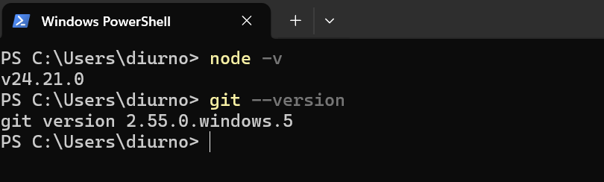
Use the next command for install global Node modules:
npm install -g bunyan gulp@4
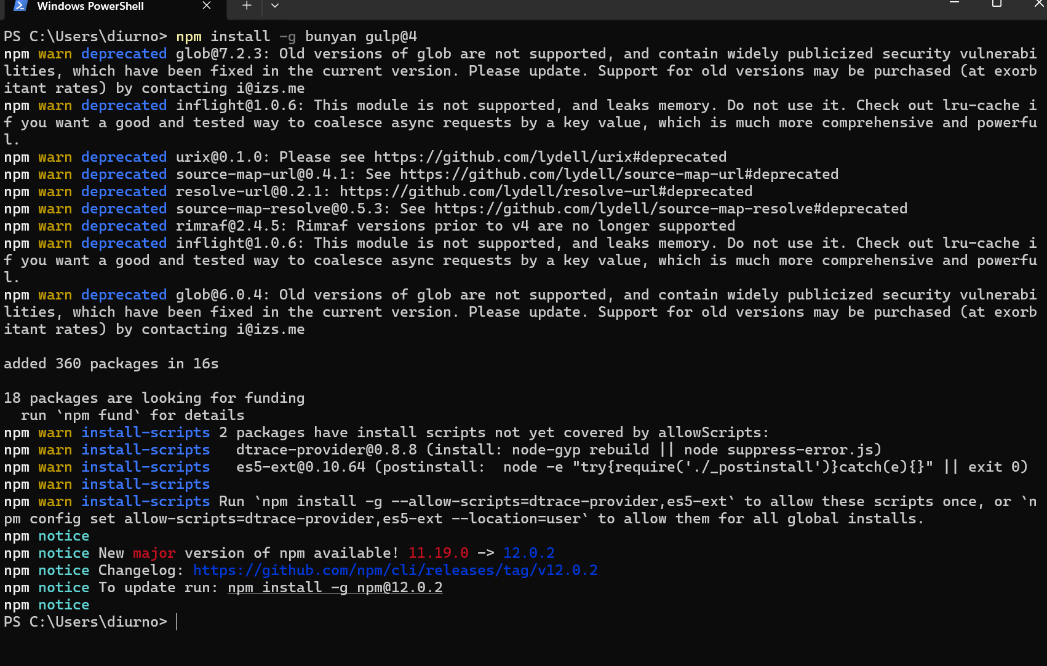
Create a folder, in my case this is the path:
“C:\Users\diurno\Desktop\Libro JS”
Clone the tutorial server into the created folder:
cd /Libro JS
git clone https://github.com/javascript-tutorial/server
git clone https://github.com/javascript-tutorial/engine server/modules/engine
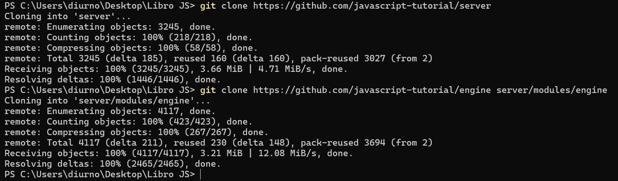
Use the next commands for clone other repository in a child folder
cd server/repo
git clone https://github.com/javascript-tutorial/es.javascript.info
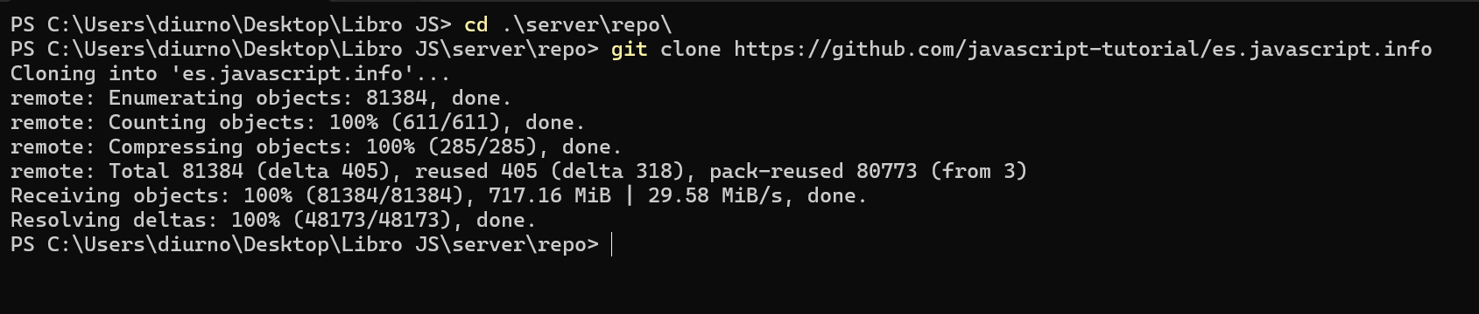
Go to the previous folder and install npm
cd ..
npm install
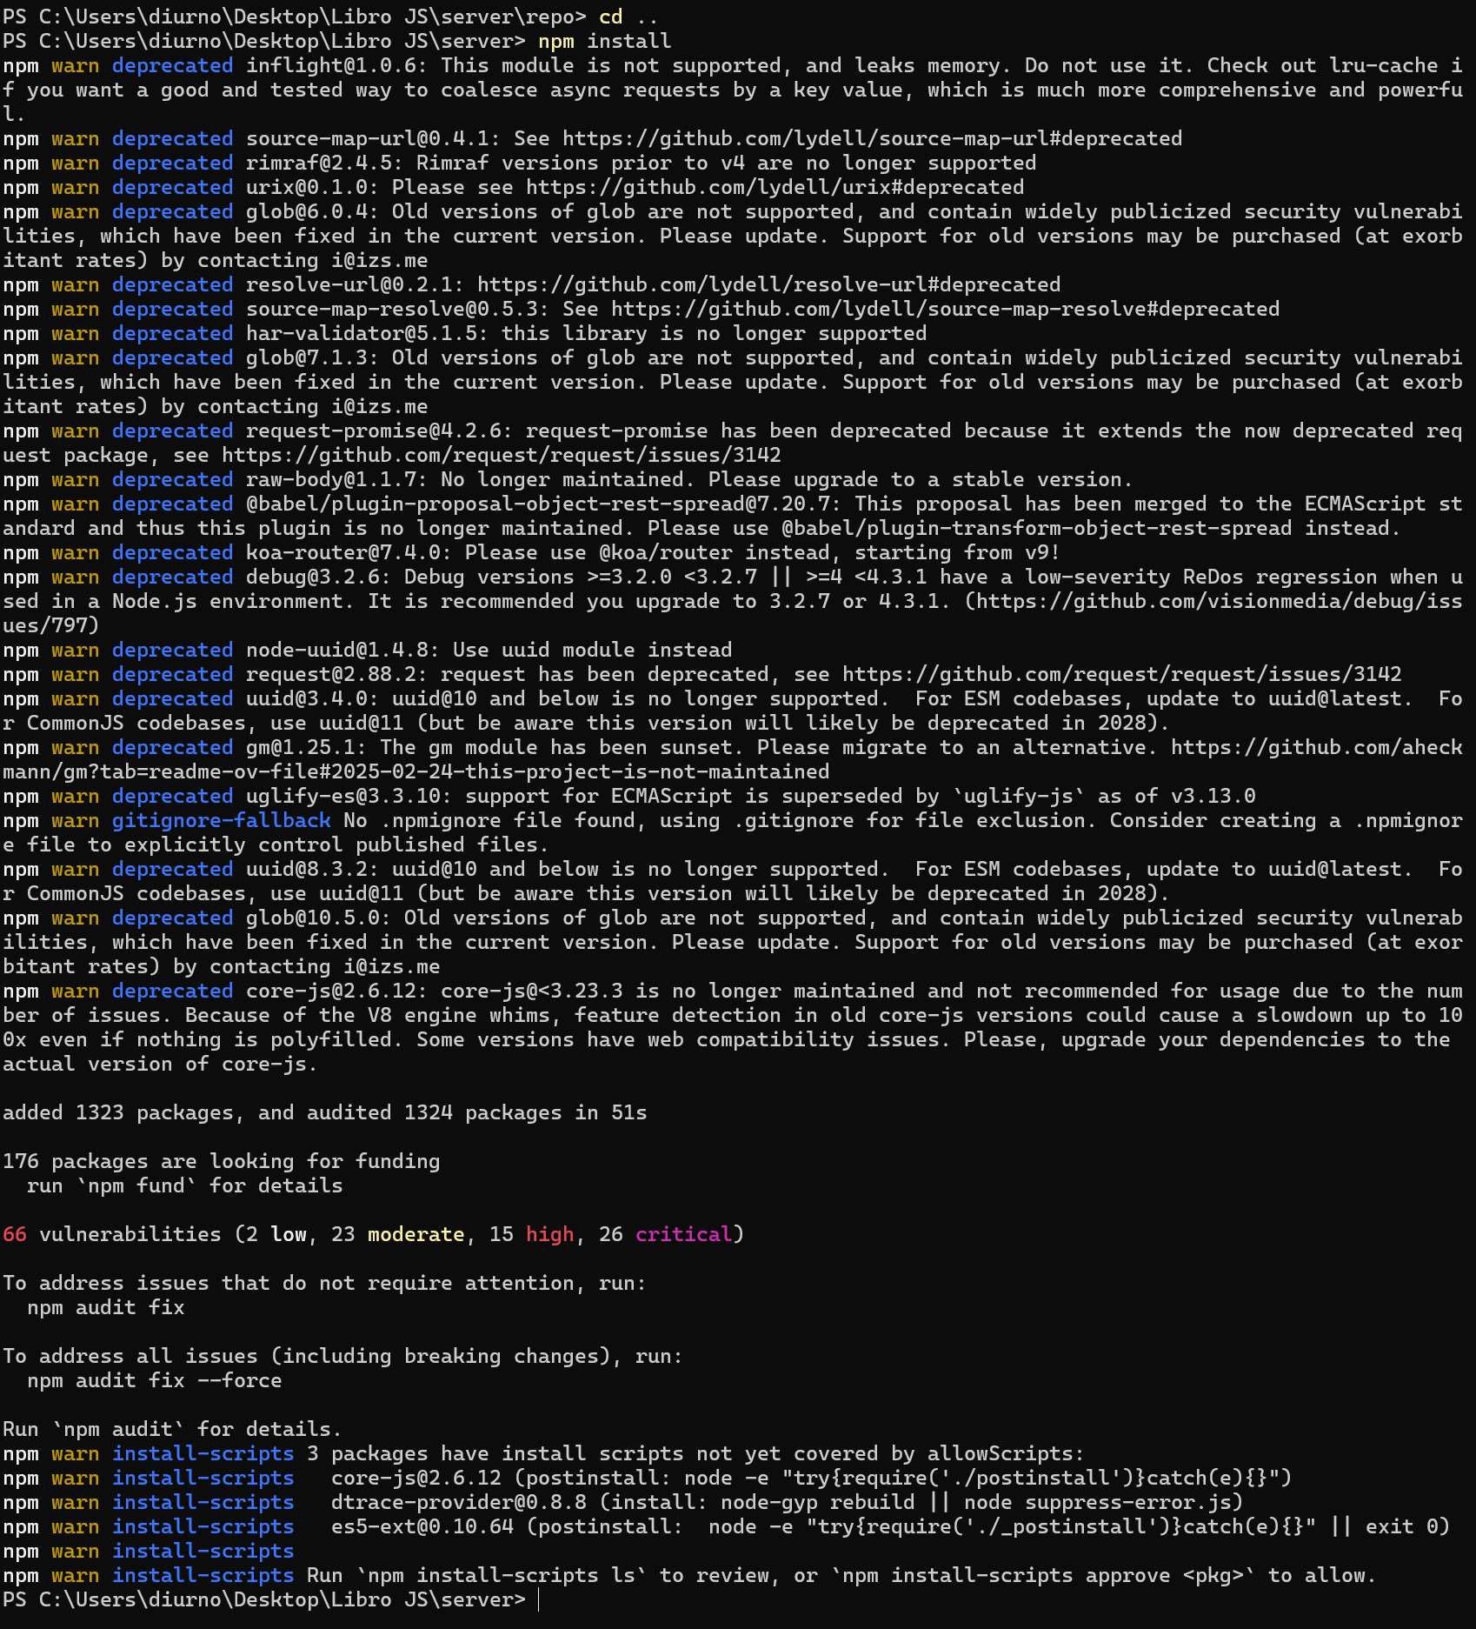
Launch the server located in server folder using:
./edit es
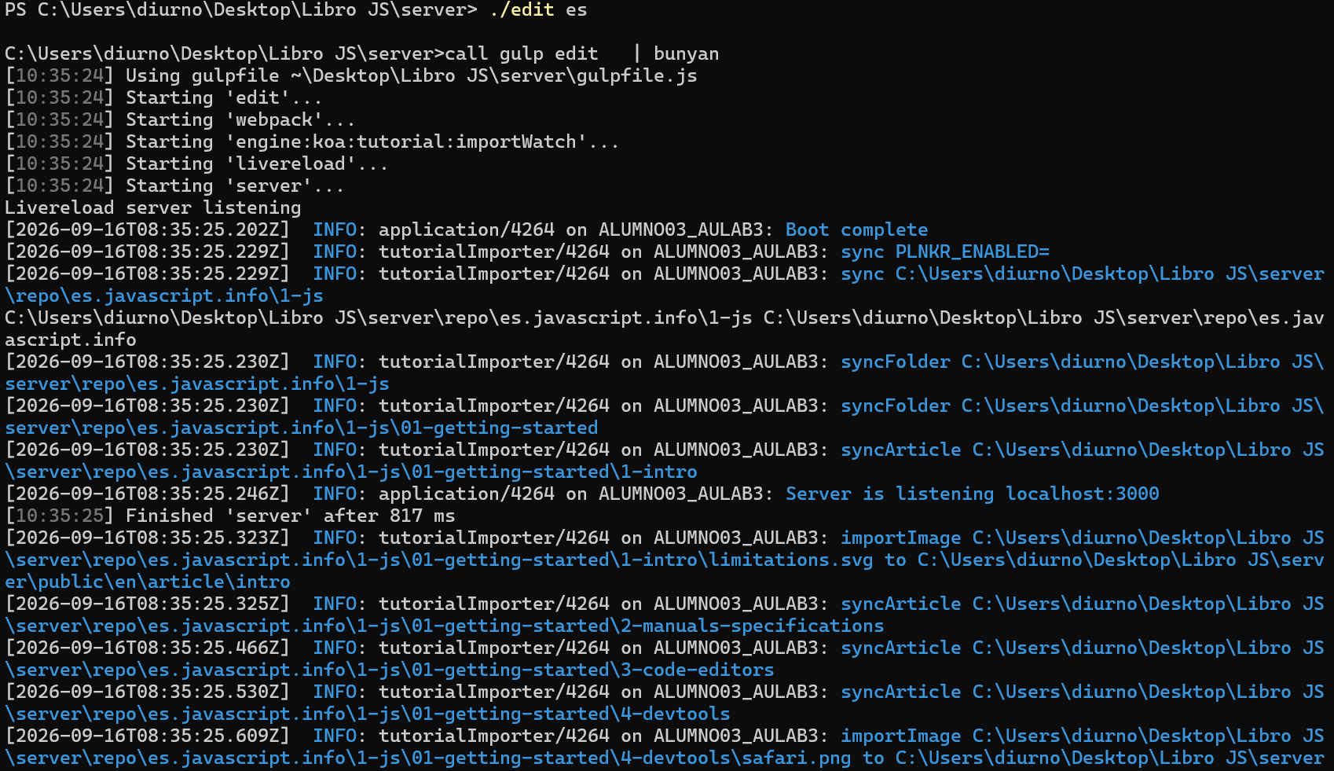
In the browser go to:
http://localhost:3000
